IE615: Data Analytics for Operations Research
Assignment 1

Arun R
163190013

1) Classification Problem

Algorithm | (W, b) and λ | Training Accuracy | Testing Accuracy
Half-spaces | W: (0.3008, 0.2295)  b: 0.2561  λ: NA | 0.9600 | 0.9600
Logistic Regression | W: (0.4897, 0.3690)  b: 0.2480  λ: NA | 0.9586 | 0.9633
SVM | W: (0.2992, 0.2283)  b: 0.2493  λ: 0.5 | 0.9600 | 0.9633

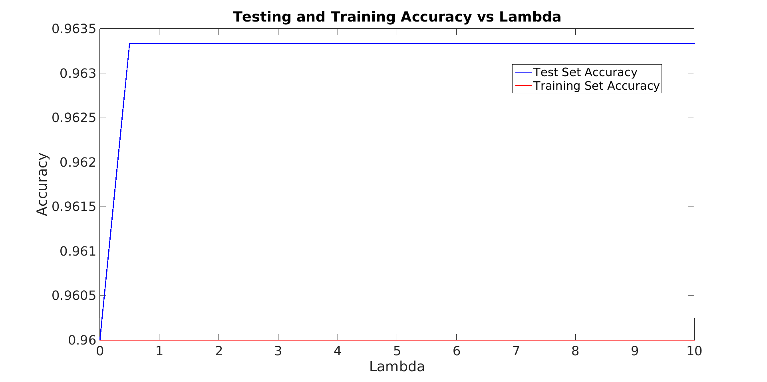

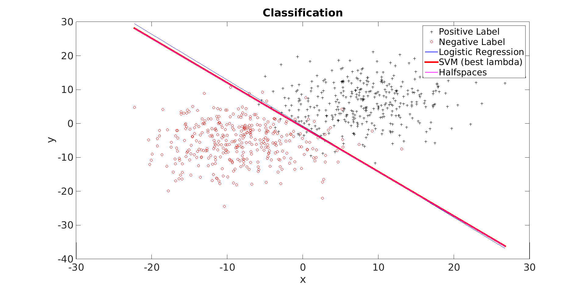
**SVM line is close to Halfspace line due to similarity in objective function

2) Regression Problem

Algorithm | (W, b) and ε | Training RMSE | Testing RMSE
Linear Regression | W:  0.115560  0.097911  0.086108  -0.189921  0.142020  0.009812  0.012037  0.107474  b = 0.995501  ε = NA | 10.275959 | 10.621989
SVR (ε loss) | W:  0.138824  0.124309  0.111942  -0.134987  0.065561  0.023483  0.035550  0.133219  b = -49.965299  ε = 0.3 | 10.525320 | 10.507872

